FLASHING USING LOCAL PYTHON OTA SERVER: (TEMPORARY SOLUTION)
SETUP:
For Client: (person in possession of voltlink)
- Change the local IP address in the AnchorhttpOTA.h file in the firmware to the developers(the person that will use the OTA for flashing) local IPV4 address.( very important)

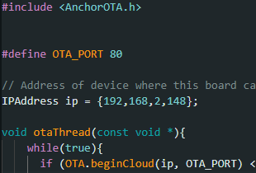

- Compile the code .
- Navigate to the folder where the binary is present :

C:\Users\eSpark\AppData\Local\arduino\sketches\BBE5FD9EA76ED39DB89B56664D98DE06
should be something like this. The last folders name will be different , you can find it by filtering the folders to the latest modified .

- Copy the “km0_km4_image2.bin file” which is the main binary file, this binary will contain the functionality for the local python OTA server
- The person which is going to use the OTA flashing method will require the board flashed with this binary and the python Download Server.
For Developer:(without voltlink)
- After having the board in possession with the firmware containing the OTA functionality
- Setup the python Download Server (may or may not require to install dependencies)

- In the DownloadServer.py change the IP address to your local IPV4 address the binary file name can also be changed if needed.

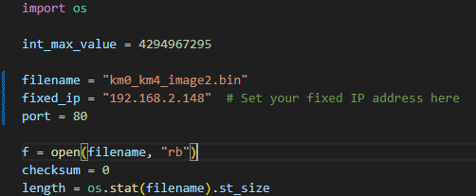

- Place the binary file “km0_km4_image2.bin” containing OTA functionality in the same directory as the Download Server.

How to Flash? :

- Now if the setup is correct and both the board and python server are on the same IP of the Developer Everything should work as intended.
- Power up the board
- The board will start to listen for the Binary file.
- Now in the terminal navigate to the directory where DownloadServer.py is present and run the following command:

On successful flash following logs will be shown in the terminal:
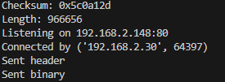
and the firmware will be updated.
- Make sure to kill the terminal where the DownloadServer is running in about 12-13 seconds after running the command or else it will keep flashing in loop.

